5th November 2017

I am testing the frequency domain code, in each area I think it could go wrong…

I am checking:

- Averaging the sound file
- Parameters into stft
- Split magnitude and phase
- Covariance calculation
- Eigen vector sorting
- Choosing dimensions
- Finding T
- Return value from robustica
- Creating spectrograms back
- Adding back phase info
- Istft
- Write back?

I had local variables called i and j, which is probably messing things up quite significantly… As well as that, I was just creating the same thing each time… I’ve hopefully changed this, and so have rerun it to see what happens.

So I’ve just found an interesting thing, by summing all the independent components back together. I get something which is recognisable as for the love of god back, but it sounds crappy (probably cos of the dimensionality reduction. Maybe I should increase the amount to preserve and try again? This also gives hints that the system is indeed working, since if it wasn’t working, then we would end up with nothing like the original track in the output. I think it is kinda working, but now I have the opposite problem as before: I have too many sources and so to construct the guitar out of this would require a lot of work. I will look at the time-domain ICA paper, but other than that, I think it may be worth looking at the wavelet transform.

Don’t think the time domain paper will be too useful, but maybe a clustering might be? I might give the clustering a quick go (say try to have 3 or 4 clusters, and see what happens). Use mutual information as distance function. Failing this, I move to wavelet transforms.

Calculating mutual information turns out to be really really complicated. So, I might have to leave that for now, since the full reconstructed signal was bad enough for the guitar that it probably wasn’t worth doing. I think its time to look at wavelet transforms.

Looking at wavelet transforms, for a start it looks like I can get much better time-frequency analysis, so I‘m gonna look at that first. It instantly looks more detailed and also hones in on the frequency area I want, so working with this might be an interesting idea.

For some reason this takes abnormally long on matlab.

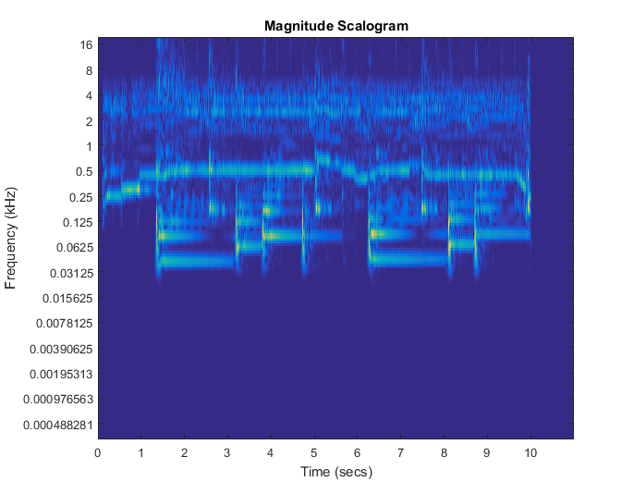

This takes ages to compute (comparatively), but at the very least is kinda accurate. You can actually see the guitar signal! I now need to see how I could use the wavelet transform to help me as its quite complicated, and I don’t quite understand it yet.

